Software Requirement Specifications
Automatic Deployment Orchestrator (ADO) DevSecOps Container Platform



Submitted by
MUHAMMAD ABRAR GHAFFAR (F22BINFT1E02032)

Submitted to
MR FAISAL SHAHZAD

Department of Information Technology
Faculty of Computing
The Islamia University of Bahawalpur

Meeting Details
Sr No | Details | Date | Supervisor Signature
Summary
Here the author will write summery of the document. They can provide a brief of the background, their findings and requirements.

Table of Contents
1. Introduction 4
1.1. Purpose 4
1.2. Scope 4
1.3. Product Perspective 4
1.4. User Characteristics 4
1.5. Similar apps and systems/Literature Review 4
1.6. Proposed Technologies 4
2. Requirements 5
2.1. Function Requirements 5
2.1.1. DEVOPS 5
2.2. Non-Functional Requirements 5
3. Use Cases and Flow of Processes 6
3.1. Use Case 1 7
4. References 8

- Introduction
The modern software landscape demands rapid, secure, and reliable software delivery. The ADO project aims to address these needs by developing an intelligent, fully automated DevSecOps platform that minimizes manual intervention in software delivery pipelines. The system is designed to ensure secure, consistent, and error-free deployments across diverse environments by integrating automation, security, and monitoring tools within a unified framework.
  - Purpose
The primary goal is to create a fully automated DevSecOps platform that streamlines the entire software delivery lifecycle (SDLC). The objectives include:
- Minimizing manual intervention in deployment pipelines.
- Ensuring secure and consistent deployments through embedded security checks (DevSecOps).
- Increasing operational efficiency and reducing downtime in real-world software delivery scenarios.

  - Scope
The ADO system's scope encompasses the full orchestration of the CI/CD pipeline, from code commit to successful deployment:
- Included (To be developed): Automated code fetching (Git), containerized builds (Docker), configuration management (Ansible), pipeline orchestration (Jenkins/Groovy), code quality scanning (SonarQube), dependency vulnerability analysis (Snyk), real-time runtime monitoring (Sysdig), and automated notifications.
- Excluded (Will not be developed): Development of the base application being deployed (ADO is the deployment platform, not the application itself). Extensive infrastructure provisioning outside of configuration management.

  - Product Perspective
The ADO platform is designed as a standalone containerized system that integrates seamlessly with existing source code repositories (Git) and target deployment environments (Linux servers/Containers). It acts as the central control plane (Orchestrator) for all deployment activities, replacing disparate manual processes with a unified automation flow.
  - User Characteristics

User Role (Actor) | Characteristics | Interaction with ADO
Developer | Requires real-time feedback on build status; Commits code. | Receives email notifications on build success/failure; Triggers pipeline via Git commit. 27
DevOps Engineer | Manages the ADO platform, configures Jenkins pipelines, monitors system health (Sysdig). | Configures CI/CD environment; Monitors logs and security reports. 28
Security Analyst | Reviews code quality and vulnerability reports (SonarQube, Snyk). | Accesses security dashboards and reports generated by the platform. 29

  - Similar apps and systems/Literature Review
There are existing CI/CD tools (e.g., GitLab CI, GitHub Actions, CircleCI) that offer similar pipeline capabilities. However, ADO’s unique value proposition is the deep, mandatory integration of DevSecOps tools (SonarQube, Snyk, Sysdig) as hard-coded quality and security gates within a single, customized Jenkins Groovy Pipeline orchestrator. This minimizes the risk of bypassing security checks, a common shortcoming in less integrated systems.
  - Proposed Technologies
The following core technologies will be used to develop and implement the ADO platform:
- Orchestration / CI/CD: Jenkins (using Groovy Pipelines)
- Source Control: Git (GitHub / BitBucket)
- Containerization: Docker
- Infrastructure / Configuration: Ansible, Linux
- DevSecOps Tools: SonarQube (Code Quality), Snyk (Dependency Vulnerability)
- Observability: Sysdig (Runtime Monitoring & Security)
- Scripting: Bash, Python, Groovy
- Methodology: CI/CD, DevSecOps

- Requirements
The ADO platform will automate the entire DevSecOps pipeline. This includes: triggering builds upon code commit, executing unit and integration tests, performing static code analysis (SonarQube) and dependency scanning (Snyk), creating consistent container images (Docker), deploying the image to the target environment, running automated configuration management (Ansible), and providing real-time monitoring and email notifications.
  - Function Requirements
Functional requirements will be provided in the standard format.
    - FR001: Automated Pipeline Orchestration

Field | Detail
Name | FR001: Automated Pipeline Orchestration 39
Purpose | To automatically trigger and manage the sequence of build, test, and deploy stages upon a new code commit to the Git repository. 40
User(s) | Developer, DevOps Engineer 41
Input | New code commit to the configured Git branch. 42
Output | Initiated Jenkins pipeline execution log; Updated deployment status. 43

    - FR002: Integrated Security and Quality Gates

Field | Detail
Name | FR002: Integrated Security and Quality Gates
Purpose | To enforce security and code quality standards by executing SonarQube and Snyk scans before proceeding to deployment.
User(s) | Developer, Security Analyst
Input | Completed code build artifact.
Output | Scan report from SonarQube (Code Quality); Scan report from Snyk (Vulnerability); Pipeline status (Fail if gate check is below threshold, Pass otherwise).

2.1.3. FR003: Environment Deployment

Field | Detail
Name | FR003: Containerized and Configuration Deployment
Purpose | To consistently deploy the built Docker container image and configure the target environment using Ansible automation.
User(s) | DevOps Engineer
Input | Successfully built and scanned Docker image; Ansible Playbook.
Output | Successful application runtime status on the target environment; Ansible configuration status log.

2.1.4. FR004: Notification System

Field | Detail
Name | FR004: Automated Status Notifications
Purpose | To immediately inform the developers about the success or failure of the pipeline execution.
User(s) | Developer
Input | Pipeline execution result (Success or Failure).
Output | Automated email notification detailing the build status, stage of failure (if applicable), and relevant logs.

  - Non-Functional Requirements

Non-Functional Requirements (Additional Details) 🛠️
Aapke maujooda Non-Functional Requirements (NFRs) mein neechay diye gaye points ko shaamil kiya gaya hai, DevSecOps platform ki quality ko aur zyada specific banane ke liye.
- Security (DevSecOps): The platform must embed security checks at every stage, including static analysis (SonarQube) and dependency scanning (Snyk).
  - Authentication: All user access (Developer, DevOps Engineer, Security Analyst) to the Jenkins dashboard and configuration files must be secured using Multi-Factor Authentication (MFA).
  - Data Encryption: Sensitive data, such as API keys, environment credentials, and secret variables used by Ansible and Jenkins, must be encrypted at rest and in transit (using TLS/SSL).
- Performance: The CI/CD pipeline execution time (from commit to deploy) must be optimized to achieve a maximum completion time of $<6 \text{ minutes}>$ for a standard deployment.
  - Response Time: The Jenkins web interface and log retrieval should load pages in under 3 seconds for all defined user roles.
  - Concurrency: The platform must be able to successfully handle 10 simultaneous pipeline executions without any degradation in the maximum completion time of 6 minutes.
- Reliability: The orchestration engine (Jenkins) must maintain an uptime of $99.9\%$ and be able to automatically restart failed stages.
  - Disaster Recovery: The Jenkins configuration, Groovy pipelines, and necessary tool settings must be backed up daily to an off-site repository to allow for recovery within $<4 \text{ hours}>$ of a catastrophic failure.
- Scalability: The platform must be scalable to handle simultaneous pipeline executions for multiple projects/teams.
  - Container Scaling: The underlying infrastructure (e.g., Jenkins agents/nodes) should be able to dynamically spin up new containerized build agents (Docker) based on the pipeline queue load to support growth of up to $50\%$ in concurrent builds.
- Maintainability: All configuration (pipelines, playbooks) must be managed as Code (Infrastructure as Code/Pipeline as Code) for easy updates and version control.
  - Code Standard: All Groovy pipeline code, Ansible playbooks, and configuration scripts must adhere to a defined internal coding standard and be subjected to a mandatory peer-review process before merging.
- Observability: The platform must integrate Sysdig for real-time monitoring and runtime security of deployed containers.
  - Alerting: The system must generate critical alerts (via email/Slack) for any security vulnerability detected at runtime by Sysdig and for any pipeline that has been in a "pending" or "running" state for more than 15 minutes.
- Usability:
  - Documentation: Comprehensive and easily accessible documentation for setting up new projects, configuring secrets, and troubleshooting failed builds must be provided for the DevOps Engineer.

- Use Cases and Flow of Processes
Use cases are the formal representation of process flow defined by functional requirements. Authors should provide a flow of events in this.

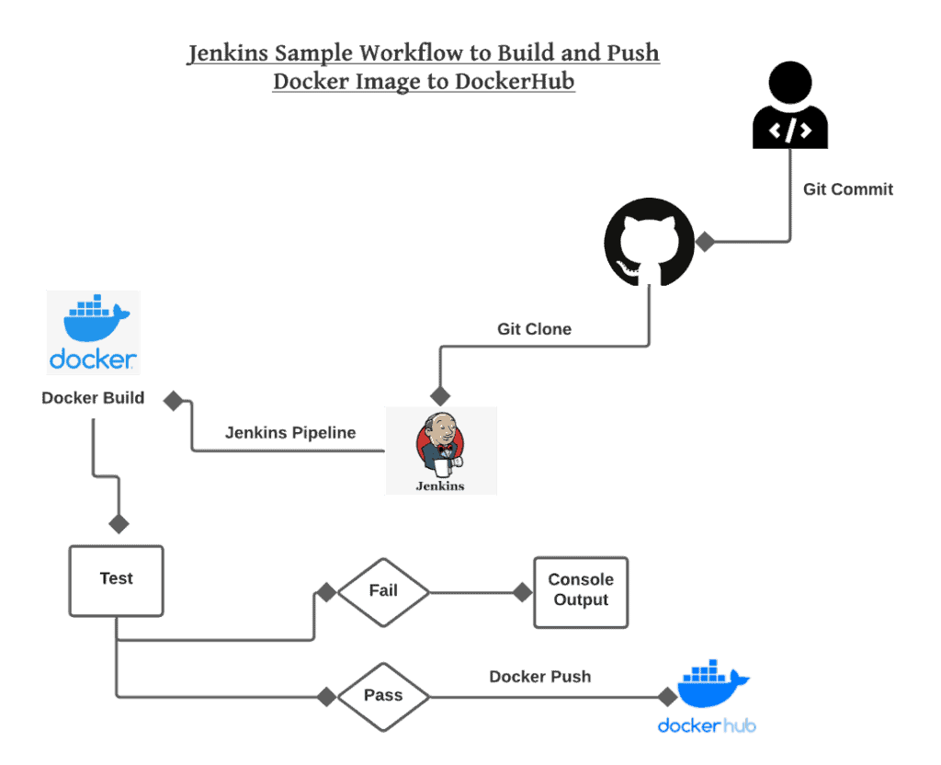

Field | Detail
ID | UC001
Name | Trigger Pipeline Execution
Description | This use case describes how a code change initiates the fully automated DevSecOps CI/CD pipeline orchestrated by Jenkins.
Requirement(s) | FR001: Automated Pipeline Orchestration 5
Actor(s) | Developer 6
Precondition | Developer has committed code to the monitored Git branch; Jenkins is connected to the Git repository.
Postcondition | Jenkins pipeline execution is successfully initiated; an execution log is generated.
Basic Flow | 1. Actor (Developer) commits and pushes code to the configured Git branch (e.g., main). 7  2. System (Git Webhook) sends a notification payload to Jenkins.  3. System (Jenkins) validates the payload and fetches the latest code. 8  4. System initiates the pipeline execution (Build, Test, Scan, Deploy sequence).  5. System updates the pipeline status to "Running."
Alternative Flow | Manual Trigger: DevOps Engineer can manually trigger the pipeline for any branch via the Jenkins dashboard interface.
Exceptions | 1. Git Connection Failure: Jenkins is unable to connect to the repository to fetch the code.  2. Invalid Payload: The Git webhook payload is malformed or unauthorized, preventing the trigger.
Diagrams | The corresponding Activity Diagram should detail the sequence from code commit through all stages (Build, Scan, Deploy) as described in the Flowchart.

- References

1) S. K. A. N. S. H. S. S. A. G. O. O. P. T. A. [“What is DevSecOps and why is it important?”]. The DevSecOps Guide. https://devsecops.org/blog/what-is-devsecops/ (accessed Dec. 5, 2025).Original DevSecOps reference.[5]G. H. W. R. K. B. 2) C. M. L. W. [“What is DevOps? A complete guide to DevOps principles, tools and practices”]. Atlassian. https://www.atlassian.com/devops (accessed Nov. 2, 2025).New: Core DevOps Methodology.[6]J. C. W. G. K. “Continuous Delivery: Reliable Software Releases through Build, Test, and Deployment Automation.” 3)Addison-Wesley Professional, 2010.New: CI/CD & Automation (Jenkins Focus).[7]B. K. G. B. “Docker: Up $\&$ Running: Shipping Reliable Containers in Production.” O’Reilly Media, 2019.

